

Student Gradebook

Project Proposal



Name: Muzammil Hjssain Enrolment NO:01-13422-115

Name: musawir khalid Enrolment No:01-134222-112

**Project Overview**

The Student Gradebook Web Application project aims to develop a comprehensive web-based system for managing users and courses within an educational institution. The system will include features for user authentication, course management, and user role-based dashboards for administrators, faculty, and students.

**Objectives**

1. **User Management:** Implement user authentication and role-based access control.
2. **Course Management:** Enable administrators and faculty to create and manage courses.
3. **Dashboard Functionality**: Provide tailored dashboards for administrators, faculty, and students.
4. **Database Integration**: Utilize a database for storing and retrieving user and course information.

**Project Components**

Frontend

1. **Homepage**: The landing page for the application.
2. **Sign In**: User authentication page.
3. **Sign Up**: User registration page.
4. **Admin Dashboard**: Dashboard for administrative tasks.
5. **Faculty Dashboard**: Dashboard for faculty-related tasks.
6. **User Management**: Interface for managing user details.
7. **Add User**: Interface for adding new users.

Backend

1. **User Authentication**: Scripts for handling user sign-in and sign-up.
2. **Course Management**: Scripts for managing courses.
3. **User Profiles**: Script for displaying user profiles.
4. **Logout**: Script for handling user logout.

Database

**Database Schema**: SQL script for creating and initializing the database.

**ER Diagram:**  
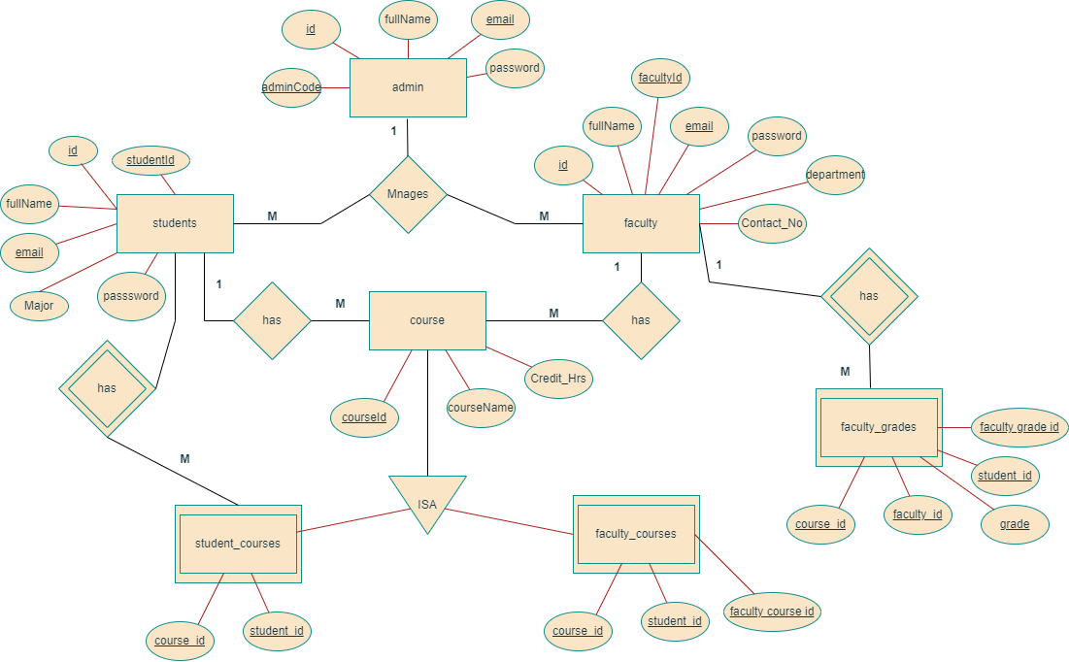

**ERD to RDM:  
